

**Department Of Computer Science**

CAC 2

**PYTHON PROGRAMMING (MCA171)**

***Submitted by:***

Akshaya Agarwal

2247207

1MCA – B

***Submitted to:***

Kavitha R

***Submitted on:***

19th September – 2022

Analysis of mobile brands and their reviews on Flipkart :

Major Attributes-

Title: Title of the product, this cell contains model name and details of mobile

ram: Display the amount of ram that particular model have.

brand: Name of the mobile manufacturer

url: product url, the link by which you can see the product on flipkart website

product id: product id or SKU in flipkart.in/com

listing id: listing id of product

highlights: highlight section available in the product page, briefs about the details of the mobile

availability: availability of product, if it is in stock or out of stock or upcoming

selling price: selling price or discounted price of the product

original price: actual price of the model or the pre-discounted price

currency: currency of selling and original price

avg rating: average rating of the product

ratings_count: total number of ratings of the product

reviews_count: total number of reviews that product received

Attributes-  
one stars count : The one star rating the product got.  
two stars count: The two star rating the product got.  
three stars count: The three star rating the product got.  
four stars count: : The four star rating the product got.

five stars count: The five star rating the product got.

Names of the graphs I used to create easy explanation of this dataset:

1.Barplot

2.Piechart

3.Boxplot

4.Scatterplot

5.Histplot

**Barplot:**

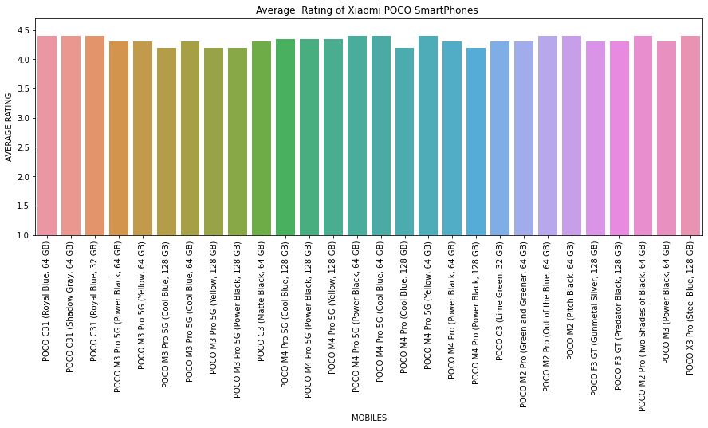

X axis : Label of x axis = Mobiles

This shows about the model of names of Brand Redmi.

Y axis: Label of y axis = Average rating

This shows the average ratings of diferent Redmi brand mobiles

This barplot explains about the various mobiles of redmi brand and their average ratings on flipkart

In this graph POCO C31 (all variants) has maximum average rating of 4.4 stars.

**Piechart:**

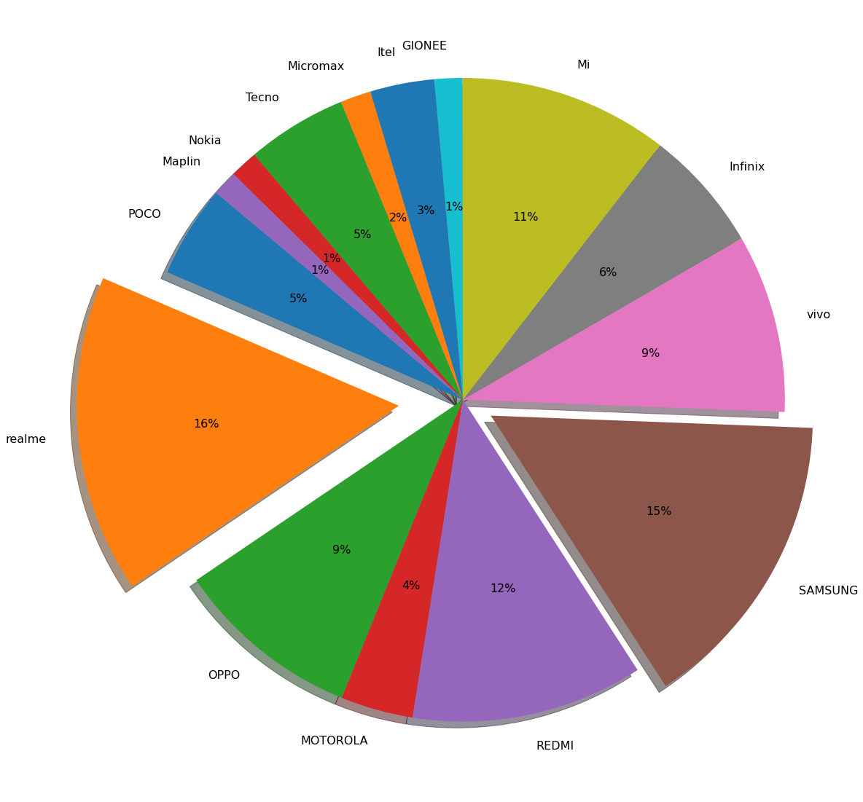

This pie chart shows the percentage of models each mobile brand have listed on flipkart.com

This maximum amount of models have been listed by Realme, their share is 16%.

The second highest number is of Samsung that is 15%.

**Boxplot:**

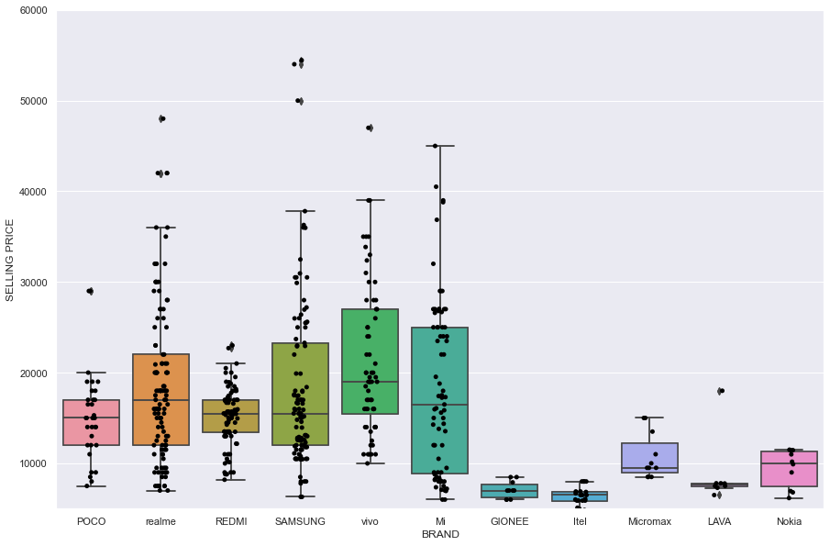

X axis : Label of x axis = Brands

This shows about all the available brands

Y axis: Label of y axis = Selling price

This shows the selling price of all brands and their models

1. Shows about the minimum i.e. lowest selling price of models of a brand.
2. Shows about the maximum i.e. maximum selling price of models of a brand.
3. Shows about the Median i.e. median selling price of models of a brand.
4. Shows about the first quartile i.e. lower quartile of selling price of models of a brand/it is the median of the lower half of data set
5. Shows about the upper quartile i.e. upper quartile of selling price of models of a brand/it is the median of the upper half of data set

This graphs shows about the maximum and minimum selling price of various models of different brands. The highest dot is the maximum price while the lowest dot is the lowest price.

**Scatterplot:**

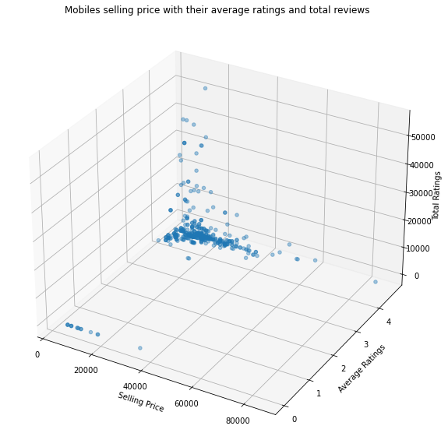

X axis : Label of x axis = Selling price

This shows about all the selling price of all brands and their models

Y axis: Label of y axis = Average ratings

This shows about the average ratings of all the brands and their models

Z axis: Label of z axis = Total ratings

This shows the number of ratings a brand and their models have received.

Mostly the selling price of mobiles lies between 10000-40000 and average ratings are 4 .0 - 4.7 stars.

**Histplot:**

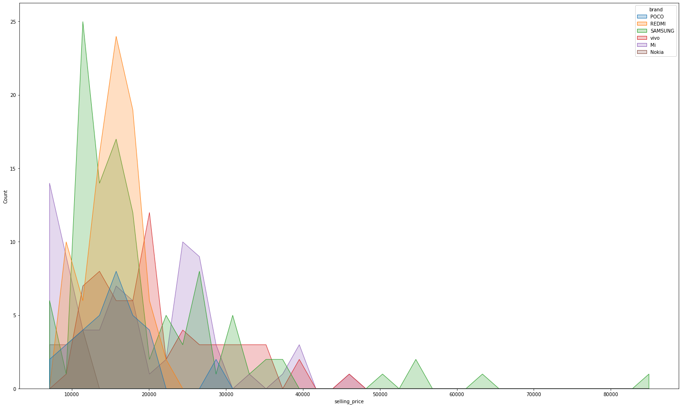

X axis : Label of x axis = Selling price

This shows about all the selling price of all brands and their models

Y axis: Label of y axis = Count

This shows about the average ratings of all the brands and their models

Legend : Labels of legend = Brands

This shows the mapping of different brands.

This graph explains about maximum number of models as per their selling price, which means that there are approx 24 mobiles in redmi brand which sells from range of Rs 10000-25000.